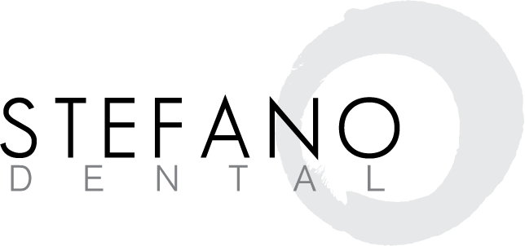
Insurance and Financial Policy
At Stefano Dental, we believe that you deserve the best care. That’s why we always present you with the best dental solution possible to treat your personal situation. Each year we provide incredible dental care to thousands of patients. Some have dental benefits, and some don’t. If you have dental benefits, congratulations! You are very fortunate. Here are some important things you should know:
- Your dental benefits are based upon a contract made between you and your employer and an insurance company. You are responsible to know your own dental insurance benefits. If you have any questions regarding your dental benefits please contact your employer or insurance company directly. Dental benefit plans will never pay for completion of your dental care. It is only meant to assist you. You are authorizing insurance payments to be made directly to the doctor, and the release of any information relating to claims.
- We currently accept all private care insurance plans (plans that do not require you to select a dentist from a list or require our office to accept a reduced fee for service.) This means that we work with literally thousands of companies. Although we can maintain computerized histories of payment by a given company, they do change; therefore it is impossible to give you a guaranteed quote at the time of service. We estimate your portion based on the most up-to-date information we have, but it is ONLY AN ESTIMATE.
- We will bill your insurance as a courtesy. If insurance does not pay within 90 days, Stefano Dental reserves the right to request payment in full for services from you and let you collect the insurance funds that are due to you. This is rare and it is important that you recognize that the insurance you have is a legal contract between YOU and your insurance company. Our office is not, and cannot be part of that legal contract.
- Ultimately, you are responsible for all charges incurred in our office.
- Stefano Dental does require payment in full for your portion at the time of service. We accept MasterCard, Visa, American Express, Discover, cash and checks. If you are in need of an extended finance option, we offer Care Credit, designed to meet your treatment plan needs on approved credit.
- We will add a 35% fee if account goes to collections.
- A specific amount of time is reserved especially for you and we strongly encourage all patients to keep their appointments. If you must change your appointment, we require at least 48 hour notice to avoid a $50 cancellation fee. This amount is donated to a local charity.
- In the event of an emergency after regular business hours a $211 emergency fee will be charged for established patients in addition to the necessary treatment fees.

X-rays and fluoride treatments will be done at the doctor’s discretion. Our office sells a variety of dental products that our staff will inform you about. I grant permission for the office staff to contact me by phone call, voice mail message, text or email, regarding appointments. HIPPA CONSENT: I have seen and been given the opportunity to review this office’s Notice of Privacy Practices. By signing this form you are consenting to our use and disclosure of your protected health information to carry out treatment, payment activities, and healthcare operations.

I agree with the above conditions.
Print Name: ____________________________________________________________Date: ___________________
Patient/Parent Signature: __________________________________________________________________________

